Stock Solutions Lab Report
Student's Name
Institution Affiliation
Course Number and Name
Instructor Name
Date

Stock Solutions Lab Report
Purpose
This lab aims to use the molar mass of a given substance to determine the mass of solute needed to create a stock solution of a specific molar concentration. Additionally, you will calculate the volume of stock solution needed to create dilution samples of particular concentrations.
Materials
- One package of Kool-Aid (assume it has a molar mass of 37.11g/mol).
- One teaspoon (assume each tsp equates to 5g).
- Tap water.
- 500 mL measuring cup (or an empty disposable water bottle) (this will serve as a stock solution container).
- 250 mL measuring cup (or half an empty disposable water bottle).
- Mixing spoon.
- Two clear drinking glasses (at least 300 mL in volume).
Procedure
Followed the instructions as indicated on the Lab Handout: Making Stock Solutions LAB.
Calculations
STOCK Solution Calculation:
the formula below is used;
C₁V₁ = C₂V₂
V1 = Volume of required stock solution to make the fresh solution
C1 = Concentration of stock solution
V2 = Closing volume of the fresh solution
C2 = Closing concentration of the fresh solution
Volume = 500 + 250 = 750 mL
However, the dilution factor (DF) is calculated by;
DF= Final Volume / Solute Volume
=750/
M_{dilution}V_{dilution} = M_{stock}V_{stock}
Mass stock= 5g+37.11g = 42.11g
Volume of stock= 500+ 250= 750mL
SAMPLE A Calculations:
Volume = 500mL
Mass= 37.11g
C₁V₁ = C₂V₂
V1 = Volume of required stock solution to make the fresh solution
C1 = Concentration of stock solution
V2 = Closing volume of the fresh solution
C2 = Closing concentration of the fresh solution
SAMPLE B Calculations:
C₁V₁ = C₂V₂
V1 = Volume of required stock solution to make the fresh solution
C1 = Concentration of stock solution
V2 = Closing volume of the fresh solution
C2 = Closing concentration of the fresh solution
Volume = 250 mL
Mass= 5g
Observations
Chart Title: A table showing the qualitative observations and photos of the prepared solutions.
Solution | Qualitative Observations | Photo
Sample A | Heterogeneous mixture.  Color variations. | 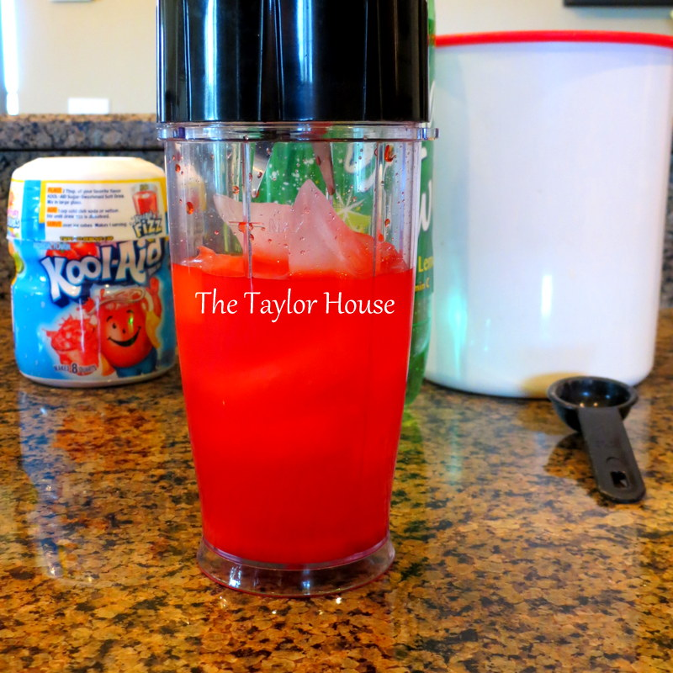
Sample B | Homogenous mixture.  Clear in color. | 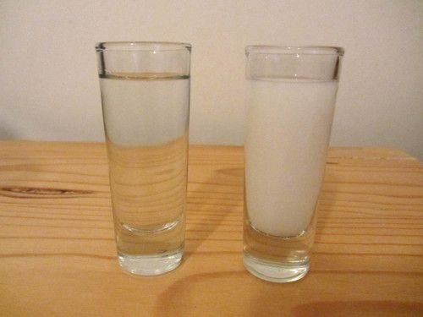
Discussion/Lab Questions
Hazards and Precautions
The hazards could be classed into four groups, including physical, electrical, biological, and chemical hazards. To start with, the chemical hazards that are perceived in the lab work area may include toxicity and corrosiveness when in contact with the skin eye or when inhaled. This can be avoided by wearing PPE (Personal Protective Equipment), including lab coats, goggles, masks, and gloves. Likewise, proper segregation of chemicals is essential.
Secondly, electrical hazards may include fire, shock, unsecured extended cords, and malfunctioning electric equipment. These may be managed by reducing the exposure of circuits and electrical extensions. Moreover, spillages may be minimized and controlled on devices or circuits.
Thirdly, biological hazards include the use of biologically reactive material, including viruses that may lead to mixed body reactions such as diseases and allergies. The best way of prevention is the practice of proper protection, proper housekeeping, and adequate storage.
Lastly, physical hazards, including accidents from moving machines, noise, slipping, heating devices, and projectiles, may be avoided by practical housekeeping and proper procedures.
Possible errors that might have resulted in inaccurate concentrations and dilutions from Part A and Part B
- Contamination of the instruments and material used. This is a standard error that results in the effects in the purity of the resulting solution. The contamination dramatically affects the concentrations of these dilutions.
- Likewise, there is a possibility of transfer inaccuracies. These lead to less precision or less accurate dispensation of the solutions. As a result, the high solutions are more likely to have elevated eves of inaccurate results. This can be minimized by using more time during the mixing of the components, which promotes the period required in doing the serial dilution.
- Procedural errors that may result from the incorrect following of some procedures in the lab manual.
- Spills
- Misinterpretation of the procedure.
- Misreading of devices and levels.
- Incorrect handling of transfer equipment, including the pipettes.
The process utilized at home requires accurate chemical calculations.
The simple process that necessitates precision of calculations is baking. Correctness is required to determine the correct mass of the reagents that are used for the use of cookies. Ina recipe for making cookies, for instance, ten cookies, the mass of every component used is necessary. For example, the mixing of 1 cup of sugar, 200 grams of flour, butter (200g), two eggs require precise mixing. The importance of precision in this typical procedure is that it enhances the baked cookies' quality; aspects like taste and durability of the cake are improved (Umland, 1984).

References
Umland, J. B. (1984). A recipe for teaching stoichiometry. Journal of Chemical Education, 61(12), 1036.

